1. Column H, ACC, needs to be grouped as listed in Barges and Zones(see excel)
2. to calculate aged NCRs: Column AF: Act Start and Column AG: Act. Finish with conditions:
1. if Column AF is blank, and it’s Column I (ACC) is not 601, input 31July 2025; for column I that is 601, input 30 Nov 2025;
2. Do the same for column AG.
3. Show total balance to go, refer to scorecard:
1. Column M (remove column B to L and Q to W) (show vs. pre. Wk)
2. Show total Balance to go, split in 2 aircrafts (show vs. pre wk)
3. Show each Aircraft’s Actuals (jobs completed) and divided into Barges (show vs. pre wk)
4 Do the same for NCOs Closed/created (show vs. pre wk)
4. Bar & line graph to show both Actuals (jobs actually completed) and staffing
5. Building a Gantt chart based on chart below
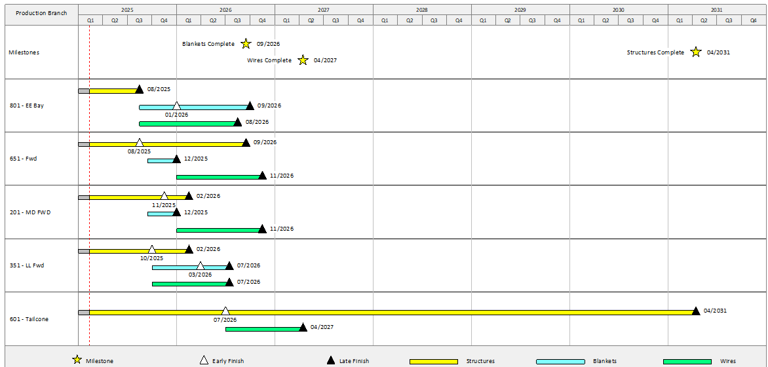

Q: tracking barges performance, what other information to include to build a better/ fuller spectrum of analysis or tracking system for their performance?
Q: will be tracking blanket and windows installation next month, what do we need for Gantt chart?
